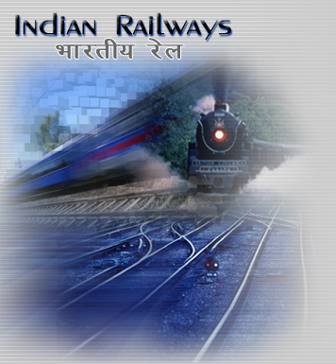

The

Railway Enquiry

System
The Project Represents The Fulfillment Of The Requirements To Award The Degree Of B.C.A.
Mr. Nitin Mandray

Ms. Sunita Goplani

Ms. Laxmi Choudhary

Developed By:-
UNIQUE COLLEGE
Bhopal(M.P.)

